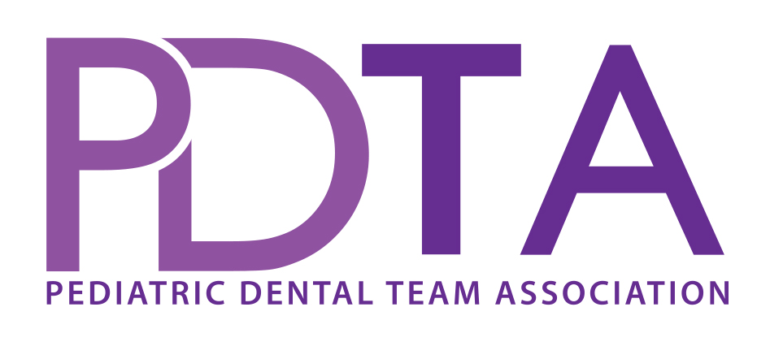

Kid Friendly Terminology

Dentists Say Adults Says Say to Child__________
Cavity Hole in tooth You have a sick tooth
You have sugar bugs in your tooth
Abscess Gum boil, Infection, Swelling There is an “owie” there
Fractured tooth Broken tooth Broken tooth
Place mouth prop into mouth Bite Block Tooth Chair to rest your teeth on
Tooth rester
Give injection Shot, Use needle Squirt some sleepy juice next to tooth
Poke, Injection Blowing a bubble next to tooth
Rubber Dam Rubber Dam Tooth raincoat, Tooth umbrella to keep
your tooth dry
Extraction Pull, Yank, Remove Wiggle a tooth, Remove a sick tooth
Cavity Prep / Prepare Drilling Clean the sugar bugs out of your tooth
the tooth Wash out the sugar bugs
Restoration/Filling Silver/White filling Silver star/ White star
Sealants Sealants, Plastic coating to Paint your tooth like fingernail polish
prevent cavities Paint a plastic baggie on your tooth to
keep sugar bugs off
Pulpotomy, Nerve treatment Root canal, Baby root canal Clean sick tooth and put medicine on it
Partial root canal
Stainless steel crown Crown, Cap Silver hat, Iron Man tooth, Super hero
tooth, Princess tooth, Tooth jewelry
Take an impression Make a model, Take impression Make a tooth statue, Tooth model
Prophy Clean teeth Clean teeth, Brush teeth, Tickle teeth,
Electric toothbrush
Nitrous Oxide “Laughing gas”, Gas, Nitrous Special perfume, Silly air, Happy air
Nitrous Oxide Mask Gas Mask Clown nose, Scuba mask, Pilot mask
Sedative Drug, Put you to sleep, Sleepy juice, Yummy medicine
Relax you
Local anesthesia Novocain, numbing Tooth sleepy juice
Topical Anesthetic Topical Tooth jelly, Special toothpaste to clean
Fluoride Treatment Fluoride Tooth vitamins, Tooth bubbles
Protective Stabilization Papoose board Butterfly blanket
Restraint Surfboard
Suction Suction, Vacuum Mister thirsty, Mister slurpy,
Magic straw
Air/Water Syringe Squirt air/water Squirt gun, Water gun
Mr. wind, Wash and dry tooth
Explorer Instrument, Pick Tooth counter, Draw magic circles
Scaler Scraper Tooth cleaner, Draw magic circles
Curing Light Light gun Tooth light, Hair dryer for teeth
Handpiece (High speed) Drill Mr. Whistle, Shower machine
Handpiece (Slow speed) Clean/polish teeth Mr. Bumpy, Tooth tickler
Rubber Dam Clamp Clamp, Ring Tooth ring
Radiograph/X-rays X-rays Tooth picture
Xray machine Xray camera Tooth camera, Take picture
Xray film / Sensor Xray Film, Cookie
Xray Lead Shield Lead Apron Apron, Blanket

