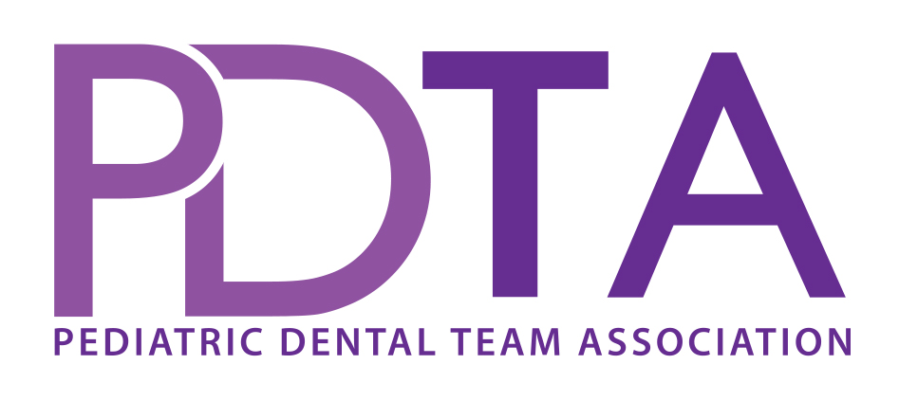

Kid – Friendly Dental Terminology Exercise

- Gather team
- Set up easel to write ideas and then vote on them later
- Go through common dental terms and decide words you want the whole office to use when discussing with parent, and words used to say to child
- A list is included in the PDTA materials to help start your discussion
- Decide as group which you like best and take to Dr. for final approval
- Write in office manual to use for future training in your office

